[](https://talk.openmrs.org/u/paul)

[**paul**Paul Biondich](https://talk.openmrs.org/u/paul)[Project Leader](https://talk.openmrs.org/g/Regenstrief)

[2019-10](https://talk.openmrs.org/t/openmrs-and-ohdsi/24930/4?u=levine)

[**@akanter**](https://talk.openmrs.org/u/akanter): a member of the OHDSI community named Lee Evans ([evans@ohdsi.org](mailto:evans@ohdsi.org)) developed a standard ETL script to move between OpenMRS and OMOP CDM in the past year. I haven’t laid my own eyes on it, but there’s also some work some of us did as well:

[https://wiki.openmrs.org/download/attachments/84476300/OpenMRS%20ETL.docx?version=1&modificationDate=1436743360000&api=v2 2](https://wiki.openmrs.org/download/attachments/84476300/OpenMRS%20ETL.docx?version=1&modificationDate=1436743360000&api=v2)

[](https://talk.openmrs.org/u/akanter)

[**akanter**Andrew Kanter](https://talk.openmrs.org/u/akanter)[Metadata & Terminology Lead](https://talk.openmrs.org/g/Leadership)

[2019-10](https://talk.openmrs.org/t/openmrs-and-ohdsi/24930/5?u=levine)

Thanks, [**@paul**](https://talk.openmrs.org/u/paul)! This is helpful. I have been following OHDSI for some time, but finally managed to get to the user conference this year. Lots going on and it would be great to have OpenMRS more involved in their data network. I think the ETL probably needs some refinement, and the tricky bits are the specific OBS that have to be moved around. Looks like you might have been working with Christian on some of that. I will reach out to Lee.

1. use WhiteRabbit (http://ohdsi.github.io/WhiteRabbit/WhiteRabbit.html) to access all openmrs tables/data and build xls file with info
2. use Rabbit-In-a-Hat (https://ohdsi.github.io/TheBookOfOhdsi/ExtractTransformLoad.html#rabbit-in-a-hat) to input xls (step 1.), show source tables (e.g. CIEL) and standard tables (e.g. SNOMED CT), link source/standard tables and write queries to move data from source to standard; note, queries might need to perform transformations of data in CIEL format to SNOMED CT format

Source Data Mapping Approach

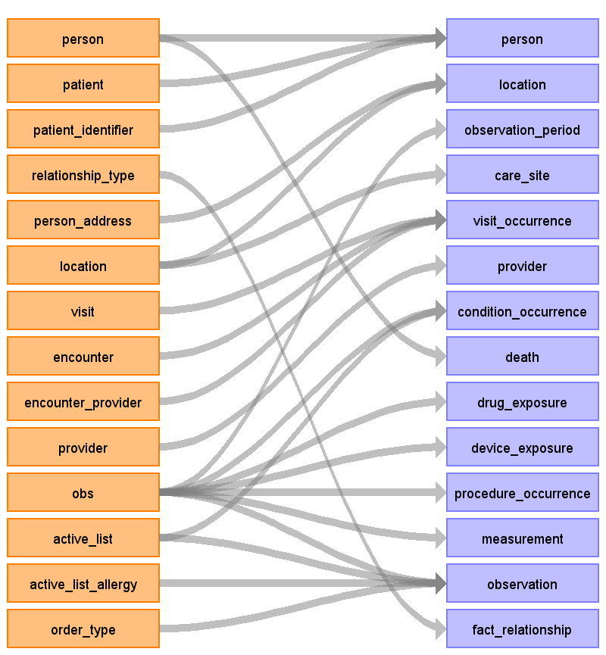

Table name: person

Reading from person

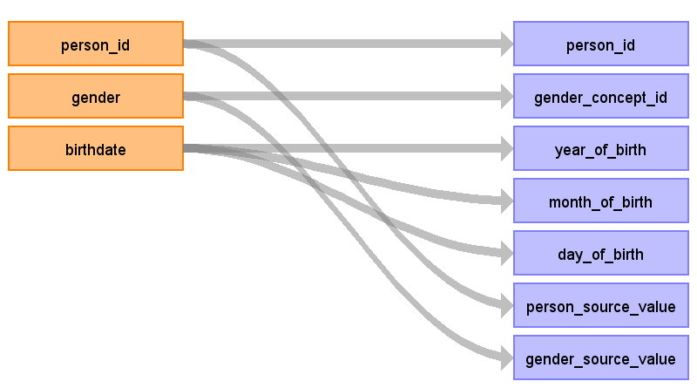

|  |  |  |  |
| --- | --- | --- | --- |
| Destination Field | Source Field | Logic | Comment |
| person_id | person_id |  |  |
| gender_concept_id | gender | CASE WHEN gender = 'F' then GENDER_CONCEPT_ID = 8532 WHEN gender = 'M' then GENDER_CONCEPT_ID = 8507 ELSE GENDER_CONCEPT_ID = 0 |  |
| year_of_birth | birthdate | YEAR_OF_BIRTH = YEAR(birthdate) |  |
| month_of_birth | birthdate | MONTH_OF_BIRTH = MONTH(birthdate) |  |
| day_of_birth | birthdate | DAY_OF_BIRTH = DAY(birthdate) |  |
| time_of_birth |  |  |  |
| race_concept_id |  |  |  |
| ethnicity_concept_id |  |  |  |
| location_id |  |  |  |
| provider_id |  |  |  |
| care_site_id |  |  |  |
| person_source_value | person_id | concatenate PERON.PERSON_ID and PATIENT_IDENTIFIER.IDENTIFIER |  |
| gender_source_value | gender |  |  |
| gender_source_concept_id |  |  |  |
| race_source_value |  |  |  |
| race_source_concept_id |  |  |  |
| ethnicity_source_value |  |  |  |
| ethnicity_source_concept_id |  |  |  |

Reading from patient

restrict records in the PERSON table to only that PERSON_ID with a PATIENT_ID in the PATIENT table

we want to keep patient_Id

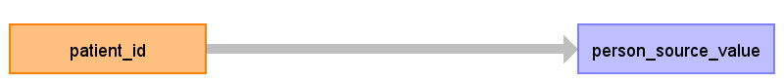

|  |  |  |  |
| --- | --- | --- | --- |
| Destination Field | Source Field | Logic | Comment |
| person_id |  |  |  |
| gender_concept_id |  |  |  |
| year_of_birth |  |  |  |
| month_of_birth |  |  |  |
| day_of_birth |  |  |  |
| time_of_birth |  |  |  |
| race_concept_id |  |  |  |
| ethnicity_concept_id |  |  |  |
| location_id |  |  |  |
| provider_id |  |  |  |
| care_site_id |  |  |  |
| person_source_value | patient_id | PERSON_SOURCE_VALUE = concatenation of PATIENT.PATIENT_ID and PATIENT_IDENTIFIER.IDENTIFIER |  |
| gender_source_value |  |  |  |
| gender_source_concept_id |  |  |  |
| race_source_value |  |  |  |
| race_source_concept_id |  |  |  |
| ethnicity_source_value |  |  |  |
| ethnicity_source_concept_id |  |  |  |

Reading from patient_identifier

If VOIDED = 1, remove from OBS, do not allow data forward to OMOP CDM

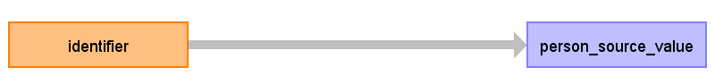

|  |  |  |  |
| --- | --- | --- | --- |
| Destination Field | Source Field | Logic | Comment |
| person_id |  |  |  |
| gender_concept_id |  |  |  |
| year_of_birth |  |  |  |
| month_of_birth |  |  |  |
| day_of_birth |  |  |  |
| time_of_birth |  |  |  |
| race_concept_id |  |  |  |
| ethnicity_concept_id |  |  |  |
| location_id |  |  |  |
| provider_id |  |  |  |
| care_site_id |  |  |  |
| person_source_value | identifier |  |  |
| gender_source_value |  |  |  |
| gender_source_concept_id |  |  |  |
| race_source_value |  |  |  |
| race_source_concept_id |  |  |  |
| ethnicity_source_value |  |  |  |
| ethnicity_source_concept_id |  |  |  |

Table name: location

Reading from location

SELECT DISTINCT address/city/state/ , because LOCATION in OpenMRS is really a caresite, and could have multple names for the same physical location

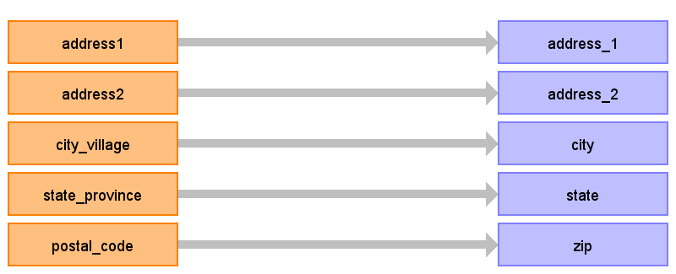

|  |  |  |  |
| --- | --- | --- | --- |
| Destination Field | Source Field | Logic | Comment |
| location_id |  |  |  |
| address_1 | address1 |  |  |
| address_2 | address2 |  |  |
| city | city_village |  |  |
| state | state_province |  |  |
| zip | postal_code |  |  |
| county |  |  |  |
| location_source_value |  |  |  |

Reading from person_address

Take the most recent person_address for the location table



|  |  |  |  |
| --- | --- | --- | --- |
| Destination Field | Source Field | Logic | Comment |
| location_id |  |  |  |
| address_1 | address1 |  |  |
| address_2 | address2 |  |  |
| city | city_village |  |  |
| state | state_province |  |  |
| zip | postal_code |  |  |
| county |  |  |  |
| location_source_value |  |  |  |

Table name: observation_period

Reading from obs

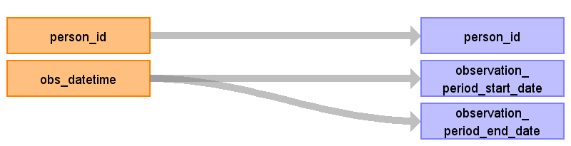

|  |  |  |  |
| --- | --- | --- | --- |
| Destination Field | Source Field | Logic | Comment |
| observation_period_id |  |  |  |
| person_id | person_id |  | ACTION: OpenMRS to determine the reasonable time window of unobservables, to infer how to build observation periods. until that's done, use first obs -> last obs. censored on last overall obs date |
| observation_period_start_date | obs_datetime | min(obs_datetime) for that patient |  |
| observation_period_end_date | obs_datetime | max(obs_datetime) for that patient |  |
| period_type_concept_id |  |  |  |

Table name: care_site

Reading from location

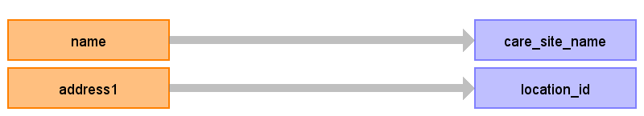

|  |  |  |  |
| --- | --- | --- | --- |
| Destination Field | Source Field | Logic | Comment |
| care_site_id |  |  |  |
| care_site_name | name |  |  |
| place_of_service_concept_id |  |  |  |
| location_id | address1 | map to CDM.LOCATION.LOCATION_ID that was derived fromt the OpenMRS.LOCATION table. |  |
| care_site_source_value |  |  |  |
| place_of_service_source_value |  |  |  |

Table name: visit_occurrence

Reading from encounter

There are likely two scenarios: If you have VISIT in the OpenMRS database, then you'd follow one logic If you don't have VISIT, you'll infer all OMOP CDM VISITS from ENCOUNTERS

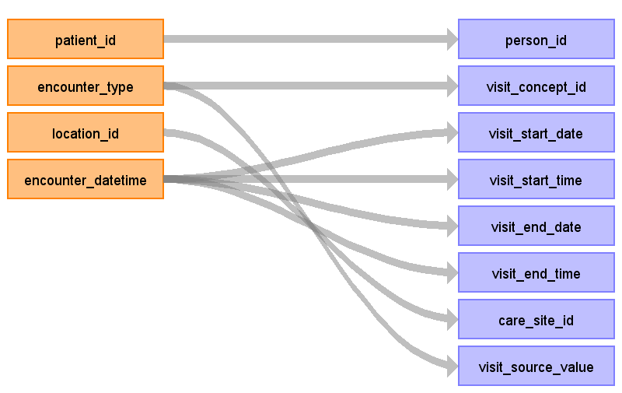

|  |  |  |  |
| --- | --- | --- | --- |
| Destination Field | Source Field | Logic | Comment |
| visit_occurrence_id |  |  |  |
| person_id | patient_id |  |  |
| visit_concept_id | encounter_type |  | ACTION: Paul to create mapping from encounter_type to VISIT_CONCEPT_ID From demo data, we know we only have outpatient visits: concept_id concept_name 9202 Outpatient Visit |
| visit_start_date | encounter_datetime |  |  |
| visit_start_time | encounter_datetime |  |  |
| visit_end_date | encounter_datetime | extract date from ENCOUNTER_DATETIME |  |
| visit_end_time | encounter_datetime |  |  |
| visit_type_concept_id |  |  | concept_id concept_name 44818518 Visit derived from EHR record |
| provider_id |  |  |  |
| care_site_id | location_id |  |  |
| visit_source_value | encounter_type |  |  |
| visit_source_concept_id |  |  |  |

Reading from encounter_provider

For each ENCOUNTER, select ENCOUNTER_PROVIDER.PROVIDER_ID where ENCOUNTER_ROLE_ID = 'Physician' (ACTION: find proper value)

Generated

|  |  |  |  |
| --- | --- | --- | --- |
| Destination Field | Source Field | Logic | Comment |
| visit_occurrence_id |  |  |  |
| person_id |  |  |  |
| visit_concept_id |  |  |  |
| visit_start_date |  |  |  |
| visit_start_time |  |  |  |
| visit_end_date |  |  |  |
| visit_end_time |  |  |  |
| visit_type_concept_id |  |  | concept_id concept_name 44818518 Visit derived from EHR record |
| provider_id |  |  |  |
| care_site_id |  |  |  |
| visit_source_value |  |  |  |
| visit_source_concept_id |  |  |  |

Reading from visit

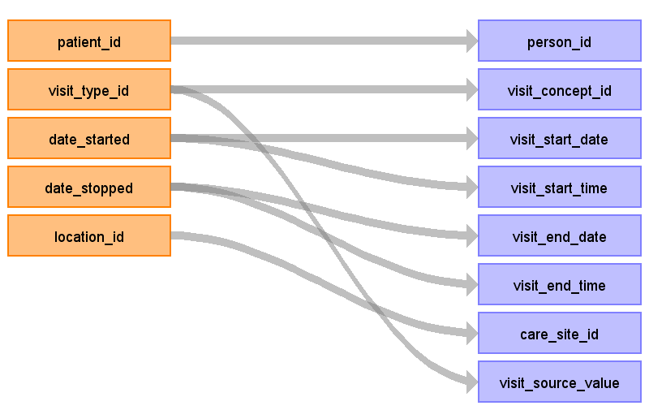

|  |  |  |  |
| --- | --- | --- | --- |
| Destination Field | Source Field | Logic | Comment |
| visit_occurrence_id |  |  |  |
| person_id | patient_id |  |  |
| visit_concept_id | visit_type_id |  | ACTION: Paul to create mapping from VIIST_TYPE_IDs to the OHDSI VISIT_CONCEPT_ID (inpatient/outpatient/ER) |
| visit_start_date | date_started | extract date from DATE_STARTED |  |
| visit_start_time | date_started | VISIT_START_TIME can store the full DATE_STARTED, don't need to extract just the time |  |
| visit_end_date | date_stopped | extract date from VISIT_END_DATE |  |
| visit_end_time | date_stopped |  |  |
| visit_type_concept_id |  |  | concept_id concept_name 44818518 Visit derived from EHR record |
| provider_id |  |  |  |
| care_site_id | location_id |  |  |
| visit_source_value | visit_type_id |  |  |
| visit_source_concept_id |  |  |  |

Table name: provider

Reading from provider

if is possible to get PROVIDER gender of YEAROFBIRTH from person table, but we didn't bother with it for now

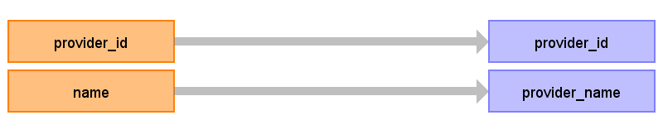

|  |  |  |  |
| --- | --- | --- | --- |
| Destination Field | Source Field | Logic | Comment |
| provider_id | provider_id |  |  |
| provider_name | name |  |  |
| npi |  |  |  |
| dea |  |  |  |
| specialty_concept_id |  |  |  |
| care_site_id |  |  |  |
| year_of_birth |  |  |  |
| gender_concept_id |  |  |  |
| provider_source_value |  |  |  |
| specialty_source_value |  |  |  |
| specialty_source_concept_id |  |  |  |
| gender_source_value |  |  |  |
| gender_source_concept_id |  |  |  |

Table name: condition_occurrence

Reading from obs

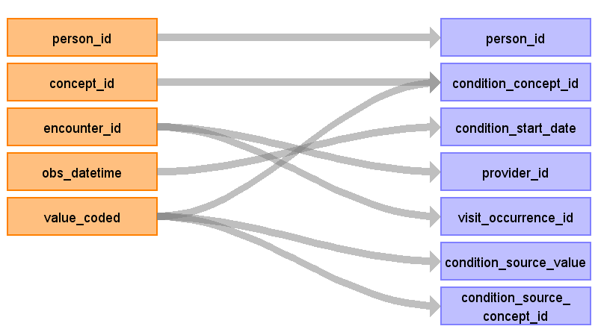

|  |  |  |  |
| --- | --- | --- | --- |
| Destination Field | Source Field | Logic | Comment |
| condition_occurrence_id |  |  |  |
| person_id | person_id |  |  |
| condition_concept_id | value_coded concept_id | VALUE_CODED maps to a OHDSI concept which had a DOMAIN = 'Condition' | limit to OBS records were value_coded is not null. ACTION: determine which CONCEPT_IDs give rise to conditions from the VALUE_CODED field 345pm DECISION: proposal moving forward: when there is a question CONCEPT_ID that refers to a OHDSI domain (ex. problem added), we will only take them when the value_coded is a vaid OHDSI concept that is mapped into vocabulary with the corresponding domain. there will be valid answers that won't be mapped to OHDSI, we can start to call them OBSERVATION, need to do our due diligence to figure out if they can be mapped elsewhere in the future. antoher option to be considered: look at value_coded and accept all concepts that meet valid OHDSI mappings to corresponding domains except for question CONCEPT_IDs known to disqualfy the record (ex. family history, problem removed) |
| condition_start_date | obs_datetime | extract date from obs_datetime |  |
| condition_end_date |  |  |  |
| condition_type_concept_id |  |  |  |
| stop_reason |  |  |  |
| provider_id | encounter_id |  | use the provider assigned to the visit for the obs |
| visit_occurrence_id | encounter_id |  | Encournter_id is used to produce VISIT, build a shadow ETL table that holds encounterId and visitId to use to make this table as we go along |
| condition_source_value | value_coded |  |  |
| condition_source_concept_id | value_coded |  |  |

Reading from active_list

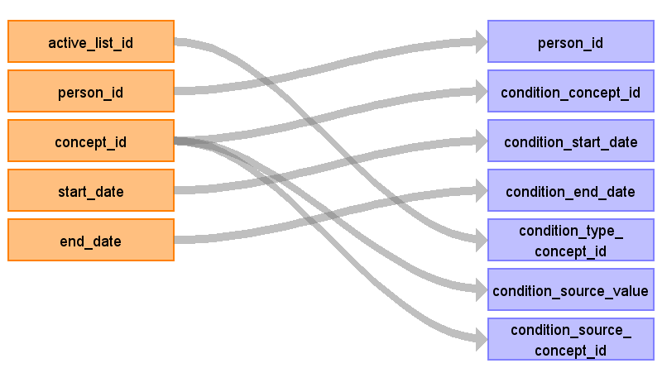

|  |  |  |  |
| --- | --- | --- | --- |
| Destination Field | Source Field | Logic | Comment |
| condition_occurrence_id |  |  |  |
| person_id | person_id |  |  |
| condition_concept_id | concept_id | Filter where CONCEPT_ID maps to OHDSI.CONCEPT_ID with domain= 'Condition' |  |
| condition_start_date | start_date |  |  |
| condition_end_date | end_date |  |  |
| condition_type_concept_id | active_list_id | concept_id concept_name 38000245 EHR problem list entry |  |
| stop_reason |  |  |  |
| provider_id |  |  |  |
| visit_occurrence_id |  |  |  |
| condition_source_value | concept_id |  |  |
| condition_source_concept_id | concept_id |  |  |

Table name: death

Reading from person

Generated

|  |  |  |  |
| --- | --- | --- | --- |
| Destination Field | Source Field | Logic | Comment |
| person_id |  |  |  |
| death_date |  |  |  |
| death_type_concept_id |  |  |  |
| cause_concept_id |  |  |  |
| cause_source_value |  |  |  |
| cause_source_concept_id |  |  |  |

Table name: drug_exposure

Reading from obs

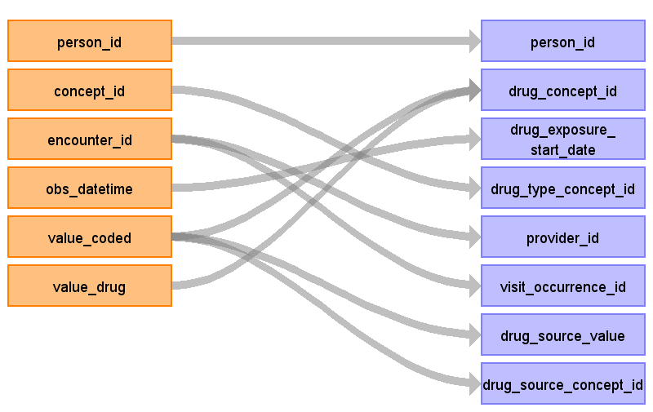

|  |  |  |  |
| --- | --- | --- | --- |
| Destination Field | Source Field | Logic | Comment |
| drug_exposure_id |  |  |  |
| person_id | person_id |  |  |
| drug_concept_id | value_coded value_drug | VALUE_CODED maps to CONCEPT to DRUG, that gets you the most granular concept, which then should be mapped to OHDSI standard CONCEPT_ID restrict to those with DOMAIN = 'Drug' | We need to figure out whether the drug makes it into value_coded, sometimes it may be value_drug if value_drug is not null use value_drug else value_coded |
| drug_exposure_start_date | obs_datetime | extract date from OBS_DATETIME |  |
| drug_exposure_end_date |  |  |  |
| drug_type_concept_id | concept_id |  | ACTION: Paul to create mapping from question concepts around drugs to DRUG_TYPE_CONCEPT_ID |
| stop_reason |  |  |  |
| refills |  |  |  |
| quantity |  |  |  |
| days_supply |  |  |  |
| sig |  |  |  |
| route_concept_id |  |  |  |
| effective_drug_dose |  |  |  |
| dose_unit_concept_id |  |  |  |
| lot_number |  |  |  |
| provider_id | encounter_id |  |  |
| visit_occurrence_id | encounter_id |  |  |
| drug_source_value | value_coded |  |  |
| drug_source_concept_id | value_coded |  |  |
| route_source_value |  |  |  |
| dose_unit_source_value |  |  |  |

Table name: device_exposure

Reading from obs

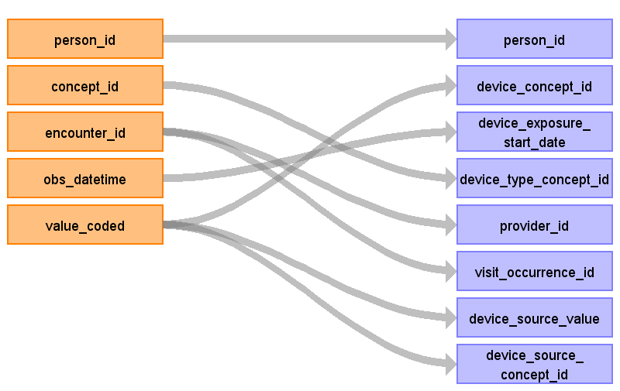

|  |  |  |  |
| --- | --- | --- | --- |
| Destination Field | Source Field | Logic | Comment |
| device_exposure_id |  |  |  |
| person_id | person_id |  |  |
| device_concept_id | value_coded | restrict to concepts where domain = 'DEVICE' |  |
| device_exposure_start_date | obs_datetime | extract date from OBS_DATETIME |  |
| device_exposure_end_date |  |  |  |
| device_type_concept_id | concept_id |  | concept_id concept_name 44818707 EHR Detail |
| unique_device_id |  |  |  |
| quantity |  |  |  |
| provider_id | encounter_id |  |  |
| visit_occurrence_id | encounter_id |  |  |
| device_source_value | value_coded |  |  |
| device_source_concept_id | value_coded |  |  |

Table name: procedure_occurrence

Reading from obs

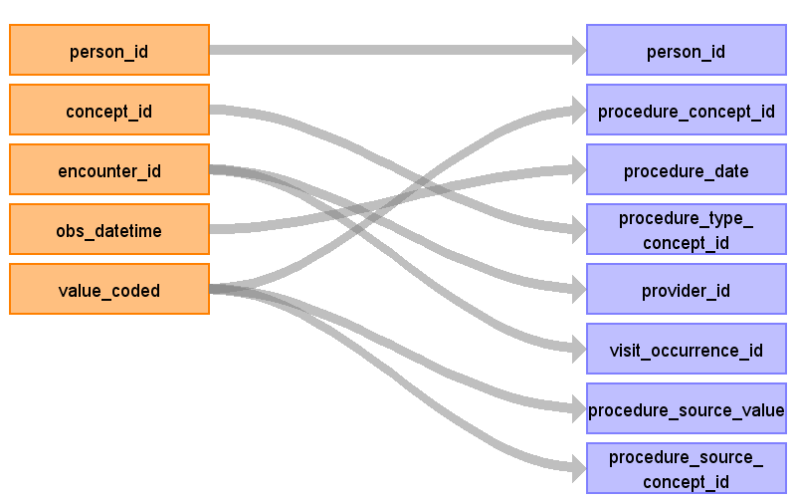

|  |  |  |  |
| --- | --- | --- | --- |
| Destination Field | Source Field | Logic | Comment |
| procedure_occurrence_id |  |  |  |
| person_id | person_id |  |  |
| procedure_concept_id | value_coded | value_coded where maps to concept with domain= 'Procedure' |  |
| procedure_date | obs_datetime |  |  |
| procedure_type_concept_id | concept_id |  | concept_id concept_name 38000275 EHR order list entry concept_id concept_name 42898141 Referral record |
| modifier_concept_id |  |  |  |
| quantity |  |  |  |
| provider_id | encounter_id |  |  |
| visit_occurrence_id | encounter_id |  |  |
| procedure_source_value | value_coded |  |  |
| procedure_source_concept_id | value_coded |  |  |
| qualifier_source_value |  |  |  |

Table name: measurement

Reading from obs

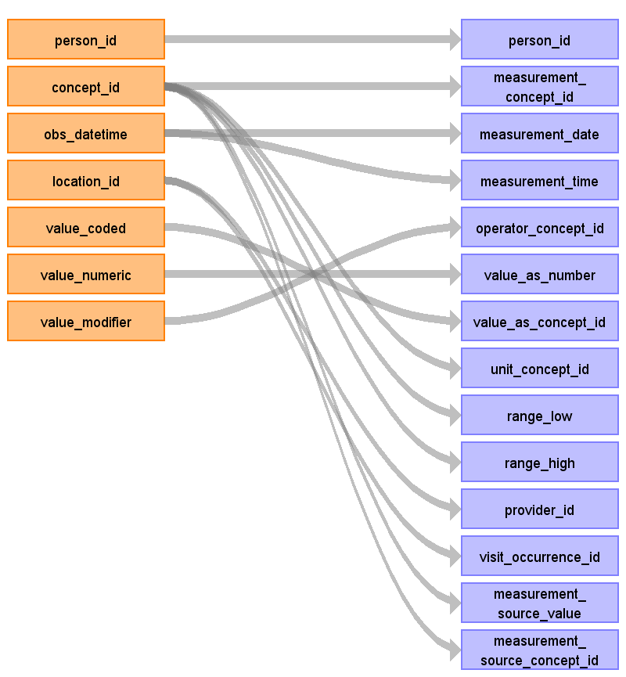

|  |  |  |  |
| --- | --- | --- | --- |
| Destination Field | Source Field | Logic | Comment |
| measurement_id |  |  |  |
| person_id | person_id |  |  |
| measurement_concept_id | concept_id | where concept_id maps to concept with domain = 'Measurement' |  |
| measurement_date | obs_datetime | extract date from OBS_DATETIME |  |
| measurement_time | obs_datetime |  |  |
| measurement_type_concept_id |  |  |  |
| operator_concept_id | value_modifier |  | ACTION: Paul to map VALUE_MODIFIER to SNOMED OPERATOR_CONCEPT_ID (<, <=, =, >, >=) |
| value_as_number | value_numeric |  |  |
| value_as_concept_id | value_coded |  |  |
| unit_concept_id | concept_id |  | ACTION: Christian, create mapping from CIEL concept_numeric to LOINC concpets for the measurement AND UCUM concept for the unit |
| range_low | concept_id |  | extract RANGE_LOW and RANGE_HIGH from CONCEPT_NUMERIC.NORMAL_HIGH and NORMAL_LOW, as part of the mapping from OpenMRS CONCEPT to OHDSI CONCEPT table for measurements |
| range_high | concept_id |  |  |
| provider_id | location_id |  |  |
| visit_occurrence_id | location_id |  |  |
| measurement_source_value | concept_id |  |  |
| measurement_source_concept_id | concept_id |  |  |
| unit_source_value |  |  |  |
| value_source_value |  |  |  |

Table name: observation

Reading from active_list_allergy

Generated

|  |  |  |  |
| --- | --- | --- | --- |
| Destination Field | Source Field | Logic | Comment |
| observation_id |  |  |  |
| person_id |  |  |  |
| observation_concept_id |  |  |  |
| observation_date |  |  |  |
| observation_time |  |  |  |
| observation_type_concept_id |  |  |  |
| value_as_number |  |  |  |
| value_as_string |  |  |  |
| value_as_concept_id |  |  |  |
| qualifier_concept_id |  |  |  |
| unit_concept_id |  |  |  |
| provider_id |  |  |  |
| visit_occurrence_id |  |  |  |
| observation_source_value |  |  |  |
| observation_source_concept_id |  |  |  |
| unit_source_value |  |  |  |
| qualifier_source_value |  |  |  |

Reading from active_list

Generated

|  |  |  |  |
| --- | --- | --- | --- |
| Destination Field | Source Field | Logic | Comment |
| observation_id |  |  |  |
| person_id |  |  |  |
| observation_concept_id |  |  |  |
| observation_date |  |  |  |
| observation_time |  |  |  |
| observation_type_concept_id |  |  |  |
| value_as_number |  |  |  |
| value_as_string |  |  |  |
| value_as_concept_id |  |  |  |
| qualifier_concept_id |  |  |  |
| unit_concept_id |  |  |  |
| provider_id |  |  |  |
| visit_occurrence_id |  |  |  |
| observation_source_value |  |  |  |
| observation_source_concept_id |  |  |  |
| unit_source_value |  |  |  |
| qualifier_source_value |  |  |  |

Reading from obs

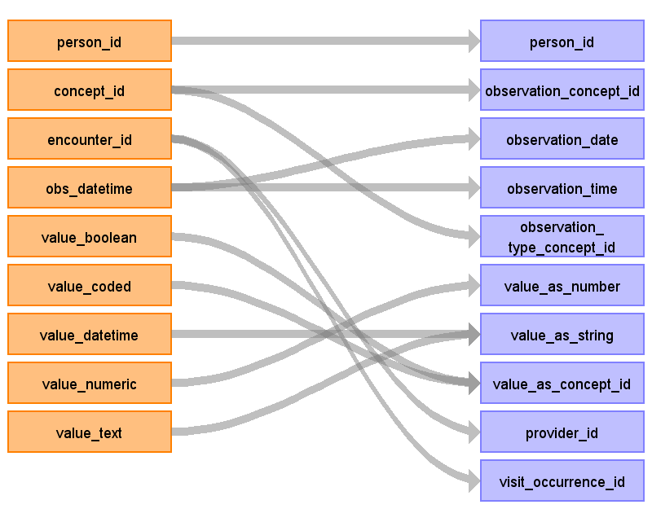

|  |  |  |  |
| --- | --- | --- | --- |
| Destination Field | Source Field | Logic | Comment |
| observation_id |  |  |  |
| person_id | person_id |  |  |
| observation_concept_id | concept_id |  |  |
| observation_date | obs_datetime |  |  |
| observation_time | obs_datetime |  |  |
| observation_type_concept_id | concept_id |  |  |
| value_as_number | value_numeric |  |  |
| value_as_string | value_datetime value_text | CONCATENATE VALUE_TEXT and VALUE_DATETIME (one of them is always null) |  |
| value_as_concept_id | value_coded value_boolean |  |  |
| qualifier_concept_id |  |  |  |
| unit_concept_id |  |  |  |
| provider_id | encounter_id |  |  |
| visit_occurrence_id | encounter_id |  |  |
| observation_source_value |  |  |  |
| observation_source_concept_id |  |  |  |
| unit_source_value |  |  |  |
| qualifier_source_value |  |  |  |

Reading from order_type

NOTE, we're missing ORDERS and DRUG_ORDER from OpenMRS that would generate infromation that would go across multipple domains based on the CONCEPT_ID

Generated

|  |  |  |  |
| --- | --- | --- | --- |
| Destination Field | Source Field | Logic | Comment |
| observation_id |  |  |  |
| person_id |  |  |  |
| observation_concept_id |  |  |  |
| observation_date |  |  |  |
| observation_time |  |  |  |
| observation_type_concept_id |  |  |  |
| value_as_number |  |  |  |
| value_as_string |  |  |  |
| value_as_concept_id |  |  |  |
| qualifier_concept_id |  |  |  |
| unit_concept_id |  |  |  |
| provider_id |  |  |  |
| visit_occurrence_id |  |  |  |
| observation_source_value |  |  |  |
| observation_source_concept_id |  |  |  |
| unit_source_value |  |  |  |
| qualifier_source_value |  |  |  |

Table name: note

Table name: specimen

Table name: fact_relationship

Reading from relationship_type

RELATIONSHIP is the table that contains parent-child linkage, which may be useful to pull over if available

Generated

|  |  |  |  |
| --- | --- | --- | --- |
| Destination Field | Source Field | Logic | Comment |
| domain_concept_id_1 |  |  |  |
| fact_id_1 |  |  |  |
| domain_concept_id_2 |  |  |  |
| fact_id_2 |  |  |  |
| relationship_concept_id |  |  |  |

Table name: procedure_cost

Table name: visit_cost

Table name: drug_cost

Table name: payer_plan_period

Table name: device_cost

Table name: drug_era

Table name: dose_era

Table name: condition_era

Table name: cdm_source

Table name: cohort

Table name: cohort_definition

Table name: cohort_attribute

Table name: attribute_definition

Appendix: source tables

Table: person

|  |  |  |  |
| --- | --- | --- | --- |
| Field | Type | Most freq. value | Comment |
| person_id | int | List truncated... |  |
| gender | varchar | F |  |
| birthdate | date | List truncated... |  |
| birthdate_estimated | tinyint | 0 |  |
| dead | tinyint | 0 |  |
| death_date | datetime |  |  |
| cause_of_death | int |  |  |
| creator | int | 1 |  |
| date_created | datetime | 2006-01-18.0 |  |
| changed_by | int |  |  |
| date_changed | datetime |  |  |
| voided | tinyint | 0 | If VOIDED = 1, remove from OBS, do not allow data forward to OMOP CDM |
| voided_by | int |  |  |
| date_voided | datetime |  |  |
| void_reason | varchar |  |  |
| uuid | char | List truncated... |  |

Table: patient

|  |  |  |  |
| --- | --- | --- | --- |
| Field | Type | Most freq. value | Comment |
| patient_id | int | List truncated... |  |
| tribe | int | 3 |  |
| creator | int | 1 |  |
| date_created | datetime | 2006-01-18.0 |  |
| changed_by | int |  |  |
| date_changed | datetime |  |  |
| voided | tinyint | 0 | If VOIDED = 1, remove from OBS, do not allow data forward to OMOP CDM |
| voided_by | int |  |  |
| date_voided | datetime |  |  |
| void_reason | varchar |  |  |
| allergy_status | varchar | Unknown |  |

Table: patient_identifier

|  |  |  |  |
| --- | --- | --- | --- |
| Field | Type | Most freq. value | Comment |
| patient_identifier_id | int | List truncated... |  |
| patient_id | int | List truncated... |  |
| identifier | varchar | List truncated... |  |
| identifier_type | int | 1 |  |
| preferred | tinyint | 0 |  |
| location_id | int | 2 |  |
| creator | int | 1 |  |
| date_created | datetime | 2006-01-18.0 |  |
| voided | tinyint | 0 |  |
| voided_by | int |  |  |
| date_voided | datetime |  |  |
| void_reason | varchar |  |  |
| uuid | char | List truncated... |  |
| date_changed | datetime |  |  |
| changed_by | int |  |  |

Table: relationship_type

|  |  |  |  |
| --- | --- | --- | --- |
| Field | Type | Most freq. value | Comment |
| relationship_type_id | int | List truncated... |  |
| a_is_to_b | varchar | List truncated... |  |
| b_is_to_a | varchar | List truncated... |  |
| preferred | int | List truncated... |  |
| weight | int | List truncated... |  |
| description | varchar | List truncated... |  |
| creator | int | List truncated... |  |
| date_created | datetime | List truncated... |  |
| uuid | char | List truncated... |  |
| retired | tinyint | List truncated... |  |
| retired_by | int | List truncated... |  |
| date_retired | datetime | List truncated... |  |
| retire_reason | varchar | List truncated... |  |

Table: person_address

|  |  |  |  |
| --- | --- | --- | --- |
| Field | Type | Most freq. value | Comment |
| person_address_id | int | List truncated... |  |
| address1 | varchar |  |  |
| address2 | varchar |  |  |
| person_id | int | List truncated... |  |
| preferred | tinyint | 0 |  |
| city_village | varchar | List truncated... |  |
| state_province | varchar |  |  |
| postal_code | varchar |  |  |
| country | varchar |  |  |
| latitude | varchar |  |  |
| longitude | varchar |  |  |
| creator | int | 1 |  |
| date_created | datetime | 2006-01-18.0 |  |
| voided | tinyint | 0 |  |
| voided_by | int |  |  |
| date_voided | datetime |  |  |
| void_reason | varchar |  |  |
| county_district | varchar |  |  |
| address3 | varchar |  |  |
| address6 | varchar |  |  |
| address5 | varchar |  |  |
| address4 | varchar |  |  |
| uuid | char | List truncated... |  |
| date_changed | datetime |  |  |
| changed_by | int |  |  |
| start_date | datetime |  |  |
| end_date | datetime |  |  |

Table: location

|  |  |  |  |
| --- | --- | --- | --- |
| Field | Type | Most freq. value | Comment |
| location_id | int | List truncated... |  |
| name | varchar | List truncated... |  |
| description | varchar |  |  |
| address1 | varchar |  |  |
| address2 | varchar |  |  |
| city_village | varchar |  |  |
| state_province | varchar |  |  |
| postal_code | varchar |  |  |
| country | varchar |  |  |
| latitude | varchar |  |  |
| longitude | varchar |  |  |
| creator | int | List truncated... |  |
| date_created | datetime | List truncated... |  |
| county_district | varchar |  |  |
| address3 | varchar |  |  |
| address6 | varchar |  |  |
| address5 | varchar |  |  |
| address4 | varchar |  |  |
| retired | tinyint | 0 |  |
| retired_by | int |  |  |
| date_retired | datetime |  |  |
| retire_reason | varchar |  |  |
| parent_location | int | List truncated... |  |
| uuid | char | List truncated... |  |
| changed_by | int | List truncated... |  |
| date_changed | datetime | List truncated... |  |

Table: visit

|  |  |  |  |
| --- | --- | --- | --- |
| Field | Type | Most freq. value | Comment |
| visit_id | int | List truncated... |  |
| patient_id | int | List truncated... |  |
| visit_type_id | int | List truncated... |  |
| date_started | datetime | List truncated... |  |
| date_stopped | datetime | List truncated... |  |
| indication_concept_id | int | List truncated... |  |
| location_id | int | List truncated... |  |
| creator | int | List truncated... |  |
| date_created | datetime | List truncated... |  |
| changed_by | int | List truncated... |  |
| date_changed | datetime | List truncated... |  |
| voided | tinyint | List truncated... | If VOIDED = 1, remove from OBS, do not allow data forward to OMOP CDM |
| voided_by | int | List truncated... |  |
| date_voided | datetime | List truncated... |  |
| void_reason | varchar | List truncated... |  |
| uuid | char | List truncated... |  |

Table: visit_type

|  |  |  |  |
| --- | --- | --- | --- |
| Field | Type | Most freq. value | Comment |
| visit_type_id | int | List truncated... |  |
| name | varchar | List truncated... |  |
| description | varchar | List truncated... |  |
| uuid | char | List truncated... |  |
| creator | int | List truncated... |  |
| date_created | datetime | List truncated... |  |
| changed_by | int | List truncated... |  |
| date_changed | datetime | List truncated... |  |
| retired | tinyint | List truncated... |  |
| retired_by | int | List truncated... |  |
| date_retired | datetime | List truncated... |  |
| retire_reason | varchar | List truncated... |  |

Table: encounter

|  |  |  |  |
| --- | --- | --- | --- |
| Field | Type | Most freq. value | Comment |
| encounter_id | int | List truncated... |  |
| patient_id | int | List truncated... |  |
| encounter_type | int | 2 |  |
| location_id | int | 1 |  |
| form_id | int |  |  |
| encounter_datetime | datetime | 2006-06-08.0 |  |
| creator | int | 1 |  |
| date_created | datetime | List truncated... |  |
| voided | tinyint | 0 | If VOIDED = 1, remove from OBS, do not allow data forward to OMOP CDM |
| voided_by | int |  |  |
| date_voided | datetime |  |  |
| void_reason | varchar |  |  |
| uuid | char | List truncated... |  |
| changed_by | int |  |  |
| date_changed | datetime |  |  |
| visit_id | int |  |  |

Table: encounter_type

|  |  |  |  |
| --- | --- | --- | --- |
| Field | Type | Most freq. value | Comment |
| encounter_type_id | int | List truncated... |  |
| name | varchar | List truncated... |  |
| description | text | List truncated... |  |
| creator | int | List truncated... |  |
| date_created | datetime | List truncated... |  |
| retired | tinyint | List truncated... |  |
| retired_by | int | List truncated... |  |
| date_retired | datetime | List truncated... |  |
| retire_reason | varchar | List truncated... |  |
| uuid | char | List truncated... |  |

Table: encounter_provider

|  |  |  |  |
| --- | --- | --- | --- |
| Field | Type | Most freq. value | Comment |
| encounter_provider_id | int | List truncated... |  |
| encounter_id | int | List truncated... |  |
| provider_id | int | 1 |  |
| encounter_role_id | int | 1 |  |
| creator | int | 1 |  |
| date_created | datetime | List truncated... |  |
| changed_by | int |  |  |
| date_changed | datetime |  |  |
| voided | tinyint | 0 | If VOIDED = 1, remove from OBS, do not allow data forward to OMOP CDM |
| date_voided | datetime |  |  |
| voided_by | int |  |  |
| void_reason | varchar |  |  |
| uuid | char | List truncated... |  |

Table: provider

|  |  |  |  |
| --- | --- | --- | --- |
| Field | Type | Most freq. value | Comment |
| provider_id | int | List truncated... |  |
| person_id | int | List truncated... |  |
| name | varchar | List truncated... |  |
| identifier | varchar | List truncated... |  |
| creator | int | List truncated... |  |
| date_created | datetime | List truncated... |  |
| changed_by | int | List truncated... |  |
| date_changed | datetime | List truncated... |  |
| retired | tinyint | List truncated... |  |
| retired_by | int | List truncated... |  |
| date_retired | datetime | List truncated... |  |
| retire_reason | varchar | List truncated... |  |
| uuid | char | List truncated... |  |
| provider_role_id | int | List truncated... |  |

Table: obs

|  |  |  |  |
| --- | --- | --- | --- |
| Field | Type | Most freq. value | Comment |
| obs_id | int | List truncated... |  |
| person_id | int | 2429 |  |
| concept_id | int | 1088 |  |
| encounter_id | int | 1559 |  |
| order_id | int |  |  |
| obs_datetime | datetime | 2006-06-08.0 |  |
| location_id | int | 1 |  |
| obs_group_id | int |  |  |
| accession_number | varchar |  |  |
| value_group_id | int |  |  |
| value_boolean | tinyint |  |  |
| value_coded | int |  |  |
| value_coded_name_id | int |  |  |
| value_drug | int |  |  |
| value_datetime | datetime |  |  |
| value_numeric | double |  |  |
| value_modifier | varchar |  |  |
| value_text | text |  |  |
| comments | varchar |  |  |
| creator | int | 1 |  |
| date_created | datetime | 2006-05-22 08:52:08.0 |  |
| voided | tinyint | 0 | If VOIDED = 1, remove from OBS, do not allow data forward to OMOP CDM |
| voided_by | int | 1 |  |
| date_voided | datetime |  |  |
| void_reason | varchar |  |  |
| value_complex | varchar |  |  |
| uuid | char | List truncated... |  |
| previous_version | int |  |  |

Table: active_list

|  |  |  |  |
| --- | --- | --- | --- |
| Field | Type | Most freq. value | Comment |
| active_list_id | int | List truncated... |  |
| active_list_type_id | int | List truncated... |  |
| person_id | int | List truncated... |  |
| concept_id | int | List truncated... |  |
| start_obs_id | int | List truncated... |  |
| stop_obs_id | int | List truncated... |  |
| start_date | datetime | List truncated... |  |
| end_date | datetime | List truncated... |  |
| comments | varchar | List truncated... |  |
| creator | int | List truncated... |  |
| date_created | datetime | List truncated... |  |
| voided | tinyint | List truncated... | If VOIDED = 1, remove from OBS, do not allow data forward to OMOP CDM |
| voided_by | int | List truncated... |  |
| date_voided | datetime | List truncated... |  |
| void_reason | varchar | List truncated... |  |
| uuid | char | List truncated... |  |

Table: active_list_allergy

|  |  |  |  |
| --- | --- | --- | --- |
| Field | Type | Most freq. value | Comment |
| active_list_id | int | List truncated... |  |
| allergy_type | varchar | List truncated... |  |
| reaction_concept_id | int | List truncated... |  |
| severity | varchar | List truncated... |  |

Table: order_type

|  |  |  |  |
| --- | --- | --- | --- |
| Field | Type | Most freq. value | Comment |
| order_type_id | int | List truncated... |  |
| name | varchar | List truncated... |  |
| description | varchar | List truncated... |  |
| creator | int | List truncated... |  |
| date_created | datetime | List truncated... |  |
| retired | tinyint | List truncated... |  |
| retired_by | int | List truncated... |  |
| date_retired | datetime | List truncated... |  |
| retire_reason | varchar | List truncated... |  |
| uuid | char | List truncated... |  |

Table: active_list_type

|  |  |  |  |
| --- | --- | --- | --- |
| Field | Type | Most freq. value | Comment |
| active_list_type_id | int | List truncated... |  |
| name | varchar | List truncated... |  |
| description | varchar | List truncated... |  |
| creator | int | List truncated... |  |
| date_created | datetime | List truncated... |  |
| retired | tinyint | List truncated... |  |
| retired_by | int | List truncated... |  |
| date_retired | datetime | List truncated... |  |
| retire_reason | varchar | List truncated... |  |
| uuid | char | List truncated... |  |

Table: allergy

|  |  |  |  |
| --- | --- | --- | --- |
| Field | Type | Most freq. value | Comment |
| allergy_id | int | List truncated... |  |
| patient_id | int | List truncated... |  |
| severity_concept_id | int | List truncated... |  |
| coded_allergen | int | List truncated... |  |
| non_coded_allergen | varchar | List truncated... |  |
| allergen_type | varchar | List truncated... |  |
| comment | varchar | List truncated... |  |
| creator | int | List truncated... |  |
| date_created | datetime | List truncated... |  |
| changed_by | int | List truncated... |  |
| date_changed | datetime | List truncated... |  |
| voided | tinyint | List truncated... |  |
| voided_by | int | List truncated... |  |
| date_voided | datetime | List truncated... |  |
| void_reason | varchar | List truncated... |  |
| uuid | char | List truncated... |  |

Table: allergy_reaction

|  |  |  |  |
| --- | --- | --- | --- |
| Field | Type | Most freq. value | Comment |
| allergy_reaction_id | int | List truncated... |  |
| allergy_id | int | List truncated... |  |
| reaction_concept_id | int | List truncated... |  |
| reaction_non_coded | varchar | List truncated... |  |
| uuid | char | List truncated... |  |

Table: appframework_component_state

|  |  |  |  |
| --- | --- | --- | --- |
| Field | Type | Most freq. value | Comment |
| component_state_id | int | List truncated... |  |
| uuid | char | List truncated... |  |
| component_id | varchar | List truncated... |  |
| component_type | varchar | List truncated... |  |
| enabled | tinyint | List truncated... |  |

Table: concept

|  |  |  |  |
| --- | --- | --- | --- |
| Field | Type | Most freq. value | Comment |
| concept_id | int | List truncated... |  |
| retired | tinyint | 0 |  |
| short_name | varchar |  |  |
| description | text |  |  |
| form_text | text |  |  |
| datatype_id | int | 4 |  |
| class_id | int | 1 |  |
| is_set | tinyint | 0 |  |
| creator | int | 1 |  |
| date_created | datetime | 2004-08-12.0 |  |
| version | varchar |  |  |
| changed_by | int | 1 |  |
| date_changed | datetime |  |  |
| retired_by | int |  |  |
| date_retired | datetime |  |  |
| retire_reason | varchar |  |  |
| uuid | char | List truncated... |  |

Table: concept_answer

|  |  |  |  |
| --- | --- | --- | --- |
| Field | Type | Most freq. value | Comment |
| concept_answer_id | int | List truncated... |  |
| concept_id | int | 1208 |  |
| answer_concept | int | 1115 |  |
| answer_drug | int |  |  |
| creator | int | 1 |  |
| date_created | datetime | 2005-02-09.0 |  |
| uuid | char | List truncated... |  |
| sort_weight | double | List truncated... |  |

Table: concept_class

|  |  |  |  |
| --- | --- | --- | --- |
| Field | Type | Most freq. value | Comment |
| concept_class_id | int | List truncated... |  |
| name | varchar | List truncated... |  |
| description | varchar | List truncated... |  |
| creator | int | List truncated... |  |
| date_created | datetime | List truncated... |  |
| retired | tinyint | List truncated... |  |
| retired_by | int | List truncated... |  |
| date_retired | datetime | List truncated... |  |
| retire_reason | varchar | List truncated... |  |
| uuid | char | List truncated... |  |

Table: concept_datatype

|  |  |  |  |
| --- | --- | --- | --- |
| Field | Type | Most freq. value | Comment |
| concept_datatype_id | int | List truncated... |  |
| name | varchar | List truncated... |  |
| hl7_abbreviation | varchar | List truncated... |  |
| description | varchar | List truncated... |  |
| creator | int | List truncated... |  |
| date_created | datetime | List truncated... |  |
| retired | tinyint | List truncated... |  |
| retired_by | int | List truncated... |  |
| date_retired | datetime | List truncated... |  |
| retire_reason | varchar | List truncated... |  |
| uuid | char | List truncated... |  |

Table: concept_description

|  |  |  |  |
| --- | --- | --- | --- |
| Field | Type | Most freq. value | Comment |
| concept_description_id | int | List truncated... |  |
| concept_id | int | List truncated... |  |
| description | text | none |  |
| locale | varchar | en |  |
| creator | int | 1 |  |
| date_created | datetime | 2004-08-12.0 |  |
| changed_by | int |  |  |
| date_changed | datetime |  |  |
| uuid | char | List truncated... |  |

Table: concept_map_type

|  |  |  |  |
| --- | --- | --- | --- |
| Field | Type | Most freq. value | Comment |
| concept_map_type_id | int | List truncated... |  |
| name | varchar | List truncated... |  |
| description | varchar |  |  |
| creator | int | 1 |  |
| date_created | datetime | 2012-05-15.0 |  |
| changed_by | int |  |  |
| date_changed | datetime |  |  |
| is_hidden | tinyint | 1 |  |
| retired | tinyint | 0 |  |
| retired_by | int |  |  |
| date_retired | datetime |  |  |
| retire_reason | varchar |  |  |
| uuid | char | List truncated... |  |

Table: concept_name

|  |  |  |  |
| --- | --- | --- | --- |
| Field | Type | Most freq. value | Comment |
| concept_id | int | 71617 |  |
| name | varchar | List truncated... |  |
| locale | varchar | en |  |
| creator | int | 1 |  |
| date_created | datetime | 2004-08-12.0 |  |
| concept_name_id | int | List truncated... |  |
| voided | tinyint | 0 |  |
| voided_by | int |  |  |
| date_voided | datetime |  |  |
| void_reason | varchar |  |  |
| uuid | char | List truncated... |  |
| concept_name_type | varchar | FULLY_SPECIFIED |  |
| locale_preferred | tinyint | 0 |  |

Table: concept_numeric

|  |  |  |  |
| --- | --- | --- | --- |
| Field | Type | Most freq. value | Comment |
| concept_id | int | List truncated... |  |
| hi_absolute | double |  |  |
| hi_critical | double |  |  |
| hi_normal | double |  |  |
| low_absolute | double |  |  |
| low_critical | double |  |  |
| low_normal | double |  |  |
| units | varchar |  |  |
| precise | tinyint | 0 |  |

Table: concept_reference_map

|  |  |  |  |
| --- | --- | --- | --- |
| Field | Type | Most freq. value | Comment |
| concept_map_id | int | List truncated... |  |
| creator | int | 1 |  |
| date_created | datetime | 2013-07-03 18:53:08.0 |  |
| concept_id | int | List truncated... |  |
| uuid | char | List truncated... |  |
| concept_reference_term_id | int | List truncated... |  |
| concept_map_type_id | int | 1 |  |
| changed_by | int | 1 |  |
| date_changed | datetime |  |  |

Table: concept_reference_source

|  |  |  |  |
| --- | --- | --- | --- |
| Field | Type | Most freq. value | Comment |
| concept_source_id | int | List truncated... |  |
| name | varchar | List truncated... |  |
| description | text | List truncated... |  |
| hl7_code | varchar | List truncated... |  |
| creator | int | List truncated... |  |
| date_created | datetime | List truncated... |  |
| retired | tinyint | List truncated... |  |
| retired_by | int | List truncated... |  |
| date_retired | datetime | List truncated... |  |
| retire_reason | varchar | List truncated... |  |
| uuid | char | List truncated... |  |

Table: concept_reference_term

|  |  |  |  |
| --- | --- | --- | --- |
| Field | Type | Most freq. value | Comment |
| concept_reference_term_id | int | List truncated... |  |
| concept_source_id | int | 21 |  |
| name | varchar |  |  |
| code | varchar | List truncated... |  |
| version | varchar |  |  |
| description | varchar |  |  |
| creator | int | 1 |  |
| date_created | datetime | 2010-04-25.0 |  |
| date_changed | datetime |  |  |
| changed_by | int | 1 |  |
| retired | tinyint | 0 |  |
| retired_by | int | 1 |  |
| date_retired | datetime |  |  |
| retire_reason | varchar |  |  |
| uuid | char | List truncated... |  |

Table: concept_set

|  |  |  |  |
| --- | --- | --- | --- |
| Field | Type | Most freq. value | Comment |
| concept_set_id | int | List truncated... |  |
| concept_id | int | List truncated... |  |
| concept_set | int | 162384 |  |
| sort_weight | double | 2 |  |
| creator | int | 1 |  |
| date_created | datetime | 2005-12-15 13:26:49.0 |  |
| uuid | char | List truncated... |  |

Table: concept_set_derived

|  |  |  |  |
| --- | --- | --- | --- |
| Field | Type | Most freq. value | Comment |
| concept_id | int | List truncated... |  |
| concept_set | int | List truncated... |  |
| sort_weight | double | 1 |  |
| uuid | char |  |  |

Table: concept_stop_word

|  |  |  |  |
| --- | --- | --- | --- |
| Field | Type | Most freq. value | Comment |
| concept_stop_word_id | int | List truncated... |  |
| word | varchar | List truncated... |  |
| locale | varchar | List truncated... |  |
| uuid | char | List truncated... |  |

Table: concept_word

|  |  |  |  |
| --- | --- | --- | --- |
| Field | Type | Most freq. value | Comment |
| concept_word_id | int | List truncated... |  |
| concept_id | int | 783 |  |
| word | varchar | HIV |  |
| locale | varchar | en |  |
| concept_name_id | int | List truncated... |  |
| weight | double | 8.7 |  |

Table: drug

|  |  |  |  |
| --- | --- | --- | --- |
| Field | Type | Most freq. value | Comment |
| drug_id | int | List truncated... |  |
| concept_id | int | List truncated... |  |
| name | varchar | List truncated... |  |
| combination | tinyint | List truncated... |  |
| dosage_form | int | List truncated... |  |
| dose_strength | double | List truncated... |  |
| maximum_daily_dose | double | List truncated... |  |
| minimum_daily_dose | double | List truncated... |  |
| route | int | List truncated... |  |
| units | varchar | List truncated... |  |
| creator | int | List truncated... |  |
| date_created | datetime | List truncated... |  |
| retired | tinyint | List truncated... |  |
| retired_by | int | List truncated... |  |
| date_retired | datetime | List truncated... |  |
| retire_reason | varchar | List truncated... |  |
| uuid | char | List truncated... |  |
| date_changed | datetime | List truncated... |  |
| changed_by | int | List truncated... |  |

Table: encounter_role

|  |  |  |  |
| --- | --- | --- | --- |
| Field | Type | Most freq. value | Comment |
| encounter_role_id | int | List truncated... |  |
| name | varchar | List truncated... |  |
| description | varchar | List truncated... |  |
| creator | int | List truncated... |  |
| date_created | datetime | List truncated... |  |
| changed_by | int | List truncated... |  |
| date_changed | datetime | List truncated... |  |
| retired | tinyint | List truncated... |  |
| retired_by | int | List truncated... |  |
| date_retired | datetime | List truncated... |  |
| retire_reason | varchar | List truncated... |  |
| uuid | char | List truncated... |  |

Table: field

|  |  |  |  |
| --- | --- | --- | --- |
| Field | Type | Most freq. value | Comment |
| field_id | int | List truncated... |  |
| name | varchar | List truncated... |  |
| description | text |  |  |
| field_type | int | 1 |  |
| concept_id | int |  |  |
| table_name | varchar |  |  |
| attribute_name | varchar |  |  |
| default_value | text |  |  |
| select_multiple | tinyint | 0 |  |
| creator | int | 1 |  |
| date_created | datetime | 2005-02-22 22:20:11.0 |  |
| changed_by | int |  |  |
| date_changed | datetime |  |  |
| retired | tinyint | 0 |  |
| retired_by | int |  |  |
| date_retired | datetime |  |  |
| retire_reason | varchar |  |  |
| uuid | char | List truncated... |  |

Table: field_type

|  |  |  |  |
| --- | --- | --- | --- |
| Field | Type | Most freq. value | Comment |
| field_type_id | int | List truncated... |  |
| name | varchar | List truncated... |  |
| description | longtext | List truncated... |  |
| is_set | tinyint | List truncated... |  |
| creator | int | List truncated... |  |
| date_created | datetime | List truncated... |  |
| uuid | char | List truncated... |  |

Table: form

|  |  |  |  |
| --- | --- | --- | --- |
| Field | Type | Most freq. value | Comment |
| form_id | int | List truncated... |  |
| name | varchar | List truncated... |  |
| version | varchar | List truncated... |  |
| build | int | List truncated... |  |
| published | tinyint | List truncated... |  |
| description | text | List truncated... |  |
| encounter_type | int | List truncated... |  |
| template | mediumtext | List truncated... |  |
| xslt | mediumtext | List truncated... |  |
| creator | int | List truncated... |  |
| date_created | datetime | List truncated... |  |
| changed_by | int | List truncated... |  |
| date_changed | datetime | List truncated... |  |
| retired | tinyint | List truncated... |  |
| retired_by | int | List truncated... |  |
| date_retired | datetime | List truncated... |  |
| retired_reason | varchar | List truncated... |  |
| uuid | char | List truncated... |  |

Table: form_field

|  |  |  |  |
| --- | --- | --- | --- |
| Field | Type | Most freq. value | Comment |
| form_field_id | int | List truncated... |  |
| form_id | int | 15 |  |
| field_id | int | List truncated... |  |
| field_number | int |  |  |
| field_part | varchar |  |  |
| page_number | int | 1 |  |
| parent_form_field | int | 356 |  |
| min_occurs | int |  |  |
| max_occurs | int |  |  |
| required | tinyint | 0 |  |
| changed_by | int | 1 |  |
| date_changed | datetime |  |  |
| creator | int | 1 |  |
| date_created | datetime | 2005-08-06.0 |  |
| sort_weight | float | List truncated... |  |
| uuid | char | List truncated... |  |

Table: global_property

|  |  |  |  |
| --- | --- | --- | --- |
| Field | Type | Most freq. value | Comment |
| property | varchar | List truncated... |  |
| property_value | mediumtext | false |  |
| description | text | List truncated... |  |
| uuid | char | List truncated... |  |
| datatype | varchar |  |  |
| datatype_config | text |  |  |
| preferred_handler | varchar |  |  |
| handler_config | text |  |  |

Table: hl7_source

|  |  |  |  |
| --- | --- | --- | --- |
| Field | Type | Most freq. value | Comment |
| hl7_source_id | int | List truncated... |  |
| name | varchar | List truncated... |  |
| description | tinytext | List truncated... |  |
| creator | int | List truncated... |  |
| date_created | datetime | List truncated... |  |
| uuid | char | List truncated... |  |

Table: hl7query_template

|  |  |  |  |
| --- | --- | --- | --- |
| Field | Type | Most freq. value | Comment |
| hl7query_template_id | int | List truncated... |  |
| uuid | char | List truncated... |  |
| creator | int | List truncated... |  |
| date_created | datetime | List truncated... |  |
| retired | tinyint | List truncated... |  |
| retired_by | int | List truncated... |  |
| date_retired | datetime | List truncated... |  |
| retire_reason | varchar | List truncated... |  |
| changed_by | int | List truncated... |  |
| date_changed | datetime | List truncated... |  |
| name | varchar | List truncated... |  |
| description | varchar | List truncated... |  |
| language | varchar | List truncated... |  |
| hl7_entity | varchar | List truncated... |  |
| template | longtext | List truncated... |  |

Table: htmlformentry_html_form

|  |  |  |  |
| --- | --- | --- | --- |
| Field | Type | Most freq. value | Comment |
| id | int | List truncated... |  |
| form_id | int | List truncated... |  |
| name | varchar | List truncated... |  |
| xml_data | mediumtext | List truncated... |  |
| creator | int | List truncated... |  |
| date_created | datetime | List truncated... |  |
| changed_by | int | List truncated... |  |
| date_changed | datetime | List truncated... |  |
| retired | tinyint | List truncated... |  |
| uuid | char | List truncated... |  |
| description | varchar | List truncated... |  |
| retired_by | int | List truncated... |  |
| date_retired | datetime | List truncated... |  |
| retire_reason | varchar | List truncated... |  |

Table: idgen_auto_generation_option

|  |  |  |  |
| --- | --- | --- | --- |
| Field | Type | Most freq. value | Comment |
| id | int | List truncated... |  |
| identifier_type | int | List truncated... |  |
| source | int | List truncated... |  |
| manual_entry_enabled | tinyint | List truncated... |  |
| automatic_generation_enabled | tinyint | List truncated... |  |
| location | int | List truncated... |  |

Table: idgen_identifier_source

|  |  |  |  |
| --- | --- | --- | --- |
| Field | Type | Most freq. value | Comment |
| id | int | List truncated... |  |
| uuid | char | List truncated... |  |
| name | varchar | List truncated... |  |
| description | varchar | List truncated... |  |
| identifier_type | int | List truncated... |  |
| creator | int | List truncated... |  |
| date_created | datetime | List truncated... |  |
| changed_by | int | List truncated... |  |
| date_changed | datetime | List truncated... |  |
| retired | tinyint | List truncated... |  |
| retired_by | int | List truncated... |  |
| date_retired | datetime | List truncated... |  |
| retire_reason | varchar | List truncated... |  |

Table: idgen_log_entry

|  |  |  |  |
| --- | --- | --- | --- |
| Field | Type | Most freq. value | Comment |
| id | int | List truncated... |  |
| source | int | List truncated... |  |
| identifier | varchar | List truncated... |  |
| date_generated | datetime | List truncated... |  |
| generated_by | int | List truncated... |  |
| comment | varchar | List truncated... |  |

Table: idgen_seq_id_gen

|  |  |  |  |
| --- | --- | --- | --- |
| Field | Type | Most freq. value | Comment |
| id | int | List truncated... |  |
| next_sequence_value | int | List truncated... |  |
| base_character_set | varchar | List truncated... |  |
| first_identifier_base | varchar | List truncated... |  |
| prefix | varchar | List truncated... |  |
| suffix | varchar | List truncated... |  |
| min_length | int | List truncated... |  |
| max_length | int | List truncated... |  |

Table: liquibasechangelog

|  |  |  |  |
| --- | --- | --- | --- |
| Field | Type | Most freq. value | Comment |
| id | varchar | List truncated... |  |
| author | varchar | bwolfe |  |
| filename | varchar | liquibase-update-to-latest.xml |  |
| dateexecuted | datetime | List truncated... |  |
| md5sum | varchar | List truncated... |  |
| description | varchar | Add Column |  |
| comments | varchar | List truncated... |  |
| tag | varchar |  |  |
| liquibase | varchar | 1.9.4 |  |
| orderexecuted | int | -1 |  |
| exectype | varchar | EXECUTED |  |

Table: liquibasechangeloglock

|  |  |  |  |
| --- | --- | --- | --- |
| Field | Type | Most freq. value | Comment |
| id | int | List truncated... |  |
| locked | tinyint | List truncated... |  |
| lockgranted | datetime | List truncated... |  |
| lockedby | varchar | List truncated... |  |

Table: location_tag

|  |  |  |  |
| --- | --- | --- | --- |
| Field | Type | Most freq. value | Comment |
| location_tag_id | int | List truncated... |  |
| name | varchar | List truncated... |  |
| description | varchar | List truncated... |  |
| creator | int | List truncated... |  |
| date_created | datetime | List truncated... |  |
| retired | tinyint | List truncated... |  |
| retired_by | int | List truncated... |  |
| date_retired | datetime | List truncated... |  |
| retire_reason | varchar | List truncated... |  |
| uuid | char | List truncated... |  |
| changed_by | int | List truncated... |  |
| date_changed | datetime | List truncated... |  |

Table: location_tag_map

|  |  |  |  |
| --- | --- | --- | --- |
| Field | Type | Most freq. value | Comment |
| location_id | int | List truncated... |  |
| location_tag_id | int | List truncated... |  |

Table: logic_token_registration

|  |  |  |  |
| --- | --- | --- | --- |
| Field | Type | Most freq. value | Comment |
| token_registration_id | int | List truncated... |  |
| creator | int | List truncated... |  |
| date_created | datetime | List truncated... |  |
| changed_by | int | List truncated... |  |
| date_changed | datetime | List truncated... |  |
| token | varchar | List truncated... |  |
| provider_class_name | varchar | List truncated... |  |
| provider_token | varchar | List truncated... |  |
| configuration | varchar | List truncated... |  |
| uuid | char | List truncated... |  |

Table: metadatasharing_imported_item

|  |  |  |  |
| --- | --- | --- | --- |
| Field | Type | Most freq. value | Comment |
| imported_item_id | int | List truncated... |  |
| uuid | char | List truncated... |  |
| classname | varchar | List truncated... |  |
| existing_uuid | char | List truncated... |  |
| date_imported | datetime | List truncated... |  |
| date_changed | datetime |  |  |
| import_type | tinyint | List truncated... |  |
| assessed | tinyint | 0 |  |

Table: metadatasharing_imported_package

|  |  |  |  |
| --- | --- | --- | --- |
| Field | Type | Most freq. value | Comment |
| imported_package_id | int |  |  |
| uuid | char |  |  |
| group_uuid | char |  |  |
| subscription_url | varchar |  |  |
| subscription_status | tinyint |  |  |
| date_created | datetime |  |  |
| date_imported | datetime |  |  |
| name | varchar |  |  |
| description | varchar |  |  |
| import_config | varchar |  |  |
| remote_version | int |  |  |
| version | int |  |  |

Table: name_phonetics

|  |  |  |  |
| --- | --- | --- | --- |
| Field | Type | Most freq. value | Comment |
| name_phonetics_id | int | List truncated... |  |
| rendered_string | varchar | List truncated... |  |
| person_name_id | int | List truncated... |  |
| field | int | List truncated... |  |
| renderer_class_name | varchar | List truncated... |  |

Table: notification_alert

|  |  |  |  |
| --- | --- | --- | --- |
| Field | Type | Most freq. value | Comment |
| alert_id | int | List truncated... |  |
| text | varchar | There was an error starting the module: RHEA SHR Adapter Web Service |  |
| satisfied_by_any | int | 1 |  |
| alert_read | int | 1 |  |
| date_to_expire | datetime |  |  |
| creator | int | 1 |  |
| date_created | datetime | List truncated... |  |
| changed_by | int | 1 |  |
| date_changed | datetime | List truncated... |  |
| uuid | char | List truncated... |  |

Table: notification_alert_recipient

|  |  |  |  |
| --- | --- | --- | --- |
| Field | Type | Most freq. value | Comment |
| alert_id | int | List truncated... |  |
| user_id | int | 1 |  |
| alert_read | int | 0 |  |
| date_changed | timestamp | List truncated... |  |
| uuid | char | List truncated... |  |

Table: patient_identifier_type

|  |  |  |  |
| --- | --- | --- | --- |
| Field | Type | Most freq. value | Comment |
| patient_identifier_type_id | int | List truncated... |  |
| name | varchar | List truncated... |  |
| description | text | List truncated... |  |
| format | varchar | List truncated... |  |
| check_digit | tinyint | List truncated... |  |
| creator | int | List truncated... |  |
| date_created | datetime | List truncated... |  |
| required | tinyint | List truncated... |  |
| format_description | varchar | List truncated... |  |
| validator | varchar | List truncated... |  |
| retired | tinyint | List truncated... |  |
| retired_by | int | List truncated... |  |
| date_retired | datetime | List truncated... |  |
| retire_reason | varchar | List truncated... |  |
| uuid | char | List truncated... |  |
| location_behavior | varchar | List truncated... |  |

Table: patientflags_displaypoint

|  |  |  |  |
| --- | --- | --- | --- |
| Field | Type | Most freq. value | Comment |
| displaypoint_id | int | List truncated... |  |
| name | varchar | List truncated... |  |
| description | varchar | List truncated... |  |
| creator | int | List truncated... |  |
| date_created | datetime | List truncated... |  |
| changed_by | int | List truncated... |  |
| date_changed | datetime | List truncated... |  |
| retired | tinyint | List truncated... |  |
| retired_by | int | List truncated... |  |
| date_retired | datetime | List truncated... |  |
| retire_reason | varchar | List truncated... |  |
| uuid | char | List truncated... |  |

Table: person_attribute

|  |  |  |  |
| --- | --- | --- | --- |
| Field | Type | Most freq. value | Comment |
| person_attribute_id | int | List truncated... |  |
| person_id | int | List truncated... |  |
| value | varchar | List truncated... |  |
| person_attribute_type_id | int | 4 |  |
| creator | int | 1 |  |
| date_created | datetime | 2008-01-02 08:32:17.0 |  |
| changed_by | int |  |  |
| date_changed | datetime |  |  |
| voided | tinyint | 0 |  |
| voided_by | int |  |  |
| date_voided | datetime |  |  |
| void_reason | varchar |  |  |
| uuid | char | List truncated... |  |

Table: person_attribute_type

|  |  |  |  |
| --- | --- | --- | --- |
| Field | Type | Most freq. value | Comment |
| person_attribute_type_id | int | List truncated... |  |
| name | varchar | List truncated... |  |
| description | text | List truncated... |  |
| format | varchar | List truncated... |  |
| foreign_key | int | List truncated... |  |
| searchable | tinyint | List truncated... |  |
| creator | int | List truncated... |  |
| date_created | datetime | List truncated... |  |
| changed_by | int | List truncated... |  |
| date_changed | datetime | List truncated... |  |
| retired | tinyint | List truncated... |  |
| retired_by | int | List truncated... |  |
| date_retired | datetime | List truncated... |  |
| retire_reason | varchar | List truncated... |  |
| edit_privilege | varchar | List truncated... |  |
| uuid | char | List truncated... |  |
| sort_weight | double | List truncated... |  |

Table: person_name

|  |  |  |  |
| --- | --- | --- | --- |
| Field | Type | Most freq. value | Comment |
| person_name_id | int | List truncated... |  |
| preferred | tinyint | 0 |  |
| person_id | int | List truncated... |  |
| prefix | varchar |  |  |
| given_name | varchar | List truncated... |  |
| middle_name | varchar | List truncated... |  |
| family_name_prefix | varchar |  |  |
| family_name | varchar | List truncated... |  |
| family_name2 | varchar |  |  |
| family_name_suffix | varchar |  |  |
| degree | varchar |  |  |
| creator | int | 1 |  |
| date_created | datetime | 2006-01-18.0 |  |
| voided | tinyint | 0 |  |
| voided_by | int |  |  |
| date_voided | datetime |  |  |
| void_reason | varchar |  |  |
| changed_by | int |  |  |
| date_changed | datetime |  |  |
| uuid | char | List truncated... |  |

Table: privilege

|  |  |  |  |
| --- | --- | --- | --- |
| Field | Type | Most freq. value | Comment |
| privilege | varchar | List truncated... |  |
| description | varchar | Core Privilege |  |
| uuid | char | List truncated... |  |

Table: providermanagement_provider_role

|  |  |  |  |
| --- | --- | --- | --- |
| Field | Type | Most freq. value | Comment |
| provider_role_id | int |  |  |
| name | varchar |  |  |
| description | varchar |  |  |
| creator | int |  |  |
| date_created | datetime |  |  |
| changed_by | int |  |  |
| date_changed | datetime |  |  |
| retired | tinyint |  |  |
| retired_by | int |  |  |
| date_retired | datetime |  |  |
| retire_reason | varchar |  |  |
| uuid | char |  |  |

Table: role

|  |  |  |  |
| --- | --- | --- | --- |
| Field | Type | Most freq. value | Comment |
| role | varchar | List truncated... |  |
| description | varchar | List truncated... |  |
| uuid | char | List truncated... |  |

Table: role_privilege

|  |  |  |  |
| --- | --- | --- | --- |
| Field | Type | Most freq. value | Comment |
| role | varchar | Privilege Level: Full |  |
| privilege | varchar | List truncated... |  |

Table: role_role

|  |  |  |  |
| --- | --- | --- | --- |
| Field | Type | Most freq. value | Comment |
| parent_role | varchar | List truncated... |  |
| child_role | varchar | List truncated... |  |

Table: scheduler_task_config

|  |  |  |  |
| --- | --- | --- | --- |
| Field | Type | Most freq. value | Comment |
| task_config_id | int | List truncated... |  |
| name | varchar | List truncated... |  |
| description | varchar | List truncated... |  |
| schedulable_class | text | List truncated... |  |
| start_time | datetime | List truncated... |  |
| start_time_pattern | varchar | List truncated... |  |
| repeat_interval | int | List truncated... |  |
| start_on_startup | int | List truncated... |  |
| started | int | List truncated... |  |
| created_by | int | List truncated... |  |
| date_created | datetime | List truncated... |  |
| changed_by | int | List truncated... |  |
| date_changed | datetime | List truncated... |  |
| uuid | char | List truncated... |  |
| last_execution_time | datetime | List truncated... |  |

Table: serialized_object

|  |  |  |  |
| --- | --- | --- | --- |
| Field | Type | Most freq. value | Comment |
| serialized_object_id | int | List truncated... |  |
| name | varchar | List truncated... |  |
| description | varchar | List truncated... |  |
| type | varchar | List truncated... |  |
| subtype | varchar | List truncated... |  |
| serialization_class | varchar | List truncated... |  |
| serialized_data | mediumtext | List truncated... |  |
| date_created | datetime | List truncated... |  |
| creator | int | List truncated... |  |
| date_changed | datetime | List truncated... |  |
| changed_by | int | List truncated... |  |
| retired | tinyint | List truncated... |  |
| date_retired | datetime | List truncated... |  |
| retired_by | int | List truncated... |  |
| retire_reason | varchar | List truncated... |  |
| uuid | char | List truncated... |  |

Table: user_property

|  |  |  |  |
| --- | --- | --- | --- |
| Field | Type | Most freq. value | Comment |
| user_id | int | List truncated... |  |
| property | varchar | List truncated... |  |
| property_value | varchar | List truncated... |  |

Table: user_role

|  |  |  |  |
| --- | --- | --- | --- |
| Field | Type | Most freq. value | Comment |
| user_id | int | List truncated... |  |
| role | varchar | List truncated... |  |

Table: users

|  |  |  |  |
| --- | --- | --- | --- |
| Field | Type | Most freq. value | Comment |
| user_id | int | List truncated... |  |
| system_id | varchar | List truncated... |  |
| username | varchar | List truncated... |  |
| password | varchar | List truncated... |  |
| salt | varchar | List truncated... |  |
| secret_question | varchar | List truncated... |  |
| secret_answer | varchar | List truncated... |  |
| creator | int | List truncated... |  |
| date_created | datetime | List truncated... |  |
| changed_by | int | List truncated... |  |
| date_changed | datetime | List truncated... |  |
| person_id | int | List truncated... |  |
| retired | tinyint | List truncated... |  |
| retired_by | int | List truncated... |  |
| date_retired | datetime | List truncated... |  |
| retire_reason | varchar | List truncated... |  |
| uuid | char | List truncated... |  |